

FARE Facts
1.Allergies are perpetrated by the immune system, and as the immune system matures with age, the allergies become stronger. Environmental allergies, like seasonal allergies, are likely to increase. On the other hand, allergic reactions to food often decrease. Many kids outgrow their food allergies.
2. teenagers with serious allergies should carry epinephrine auto injectors. They are very important. If the allergic reaction is severe, like anaphylaxis, a dose of epinephrine from an epinephrine auto injector buys time. The shot gives the teenager a chance to get to the hospital. Epinephrine auto injectors are especially important for teenagers because the risk of death from food allergies is higher than for younger kids.
3. Teenagers have more severe allergic reactions because the immune system is stronger, so the allergic reaction can be stronger. For example, the risk of dying from a bee sting is much higher after the age of 16. Another reason is that teenagers engage in risk-taking behaviors. They may be less vigilant about avoiding an allergen. Lastly, teenagers may forget to carry their EpiPen.
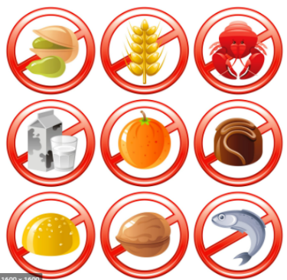
FARE Food
1.Nutties for a Change – Individually, they are each a bit shy, but when best friends Tiffani Pope (multiple food allergies) and Mariana Trejos (fragrance allergy) team up, a lively website with recipes, contests, and a “Teen Guide” are the result.
2.Teens with Food Allergies – Hannah Lank is a doer, and it shows in her honest, informational, and supportive articles. She openly shares her successes, her challenges, and useful lessons.
3.Allergy Alli – Allison Davin is an expressive girl with a lot to share. Her posts with stories, tips, recipes and pictures provide amazing outreach to other food allergic teens.
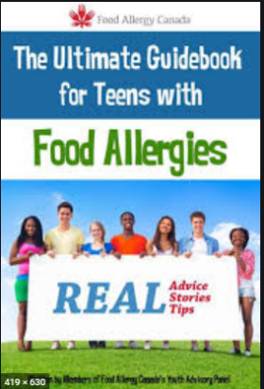
FARE Fun for teens
1.FARE Teen Summit – In 2018, this popular summit will be part of the annual FARECon summit, so parents and teens can arrive together, then go their separate ways to learn and share. The teen summit offers food-allergic teens the opportunity to meet others just like them, discuss social issues related to allergies, and have fun. See student Michael Mandanas report on the summit experience here.
2. FARE’s Teen Advisory Group (TAG) – A nationwide program where teen members get involved in online projects, youth awareness programs, peer-to-peer mentoring, and representing their geographic region. Food allergic teens can apply to join during designated times.
3.FARE’s Teen Food Allergy Support Group – This private Facebook group brings together members of TAG, but also welcomes other food allergic teens simply looking for like-minded friends and support.
Calling All Tweens, Teens and Young Adults!
FARE Virtual Teen Talk
Date: Saturday, February 27, 2021,5;00pm ET,Topic of the Month : Friendship
www.foodallergy.org
Karen Clydesdale, Chair, North West District GFWC GA President’s Special Project

