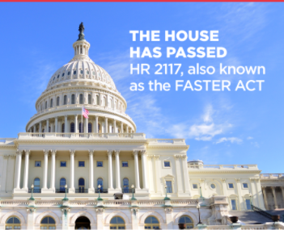

FARE Facts
1.FARE advocates have sent more than 8000 emails and held hundreds of virtual and in person meetings with members of Congress and their staff

2.In early March FARE’s Inaugural Courage at Congress brought 150 food allergy advocates from across the nation to meet with members of Congress and staff from more than 100 miles.

3. On November 17, 2020, The United States House of Representatives unanimously passed The Food Allergy Safety, Treatment, Education and Research (FASTER) Act of 2019. This bill would add sesame as the ninth top allergen.
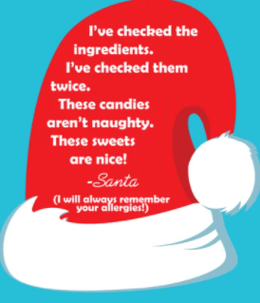
FARE Food
Free2b
When it comes to chocolate treats that are 100% vegan, gluten-free, and allergen-free, Free2B is worth checking out. Their products are free from the top 12 allergens! With flavors like Dark Chocolate, Rice Chocolate, Peppermint Dark Chocolate, and Blueberry Crunch, they have some good options to choose from
No Whey Foods
If you feel like splurging, No Whey Foods has some super cute treats to choose from such as Vegan Advent Calendar. They are 100% free of milk, peanuts, tree nuts, gluten, eggs, soy, and artificial colors/flavors. Plus, they are vegan and kosher!
Amanda’s Own
Now this one is adorable! They have a ton of cute Christmas and Hanukkah treats (all of which are free from the top 8 allergens) your kids will love. They also have allergy-friendly cookie dough for those of you who love to get your bake on during the holidays. Just be sure to order by December 16th to get them on time.
https://awefilledhomemaker.com/allergen-friendly-christmas-treats/

FARE Fun for kids
For information on building allergy friendly Gingerbread houses, advent calendars and other holiday treats visit:
https://lilallergyadvocates.com/allergy-friendly-gingerbread-house/

Help Others: The holidays are the perfect time of year to reach out to others in need. Have your child work on a project to help people in your community. Children can gather clothing, used books, or canned food items to donate. They can also create crafts that can be used to decorate local shelters, food pantries, nursing homes, or community centers.
Be Creative: Make ornaments, cards, stockings or other crafts. ** There are many non-food craft ideas on Pinterest, like decorating Gingerbread people or houses made from foam, paper or cardboard. Make snowmen out of socks and stuff with cotton batting
** Be sure to check craft ingredients for allergens. For more ideas and inspiration, please visit:
https://community.kidswithfoodallergies.org/blog/tips-to-safely-celebrate-christmas-with-food-allergies-1

