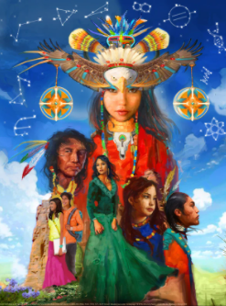
November, National Native American Heritage Month, provides Native peoples the opportunity to celebrate their diverse and rich cultures, traditions, as well as educate non-Natives about tribes, raise awareness about the unique history of the United States and Native peoples, and acknowledge the strength and resiliency of Native survival. Currently, there are no Indian reservations or federally recognized Native American tribes in Georgia however, there are still native people living in our state who may need our help. Domestic Violence is not a native American tradition, it was introduced through colonization. Now, there is a wonderful organization call StrongHearts. Native Americans who have experienced domestic, dating and sexual violence can now get culturally appropriate support.


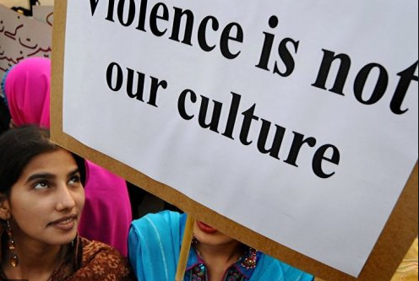
The StrongHearts Native Helpline (1-844-762-8483) is a culturally appropriate, confidential, and anonymous service to American Indians, Alaska Natives and Native Hawaiians who are experiencing abuse or know someone who is being impacted by domestic violence. StrongHearts advocates are available 7 a.m. to 10 p.m. CST, seven days a week, and are trained with an understanding of intimate partner violence, including spiritual or cultural abuse. Our advocates can provide support and validation, safety planning and access to resources in your community.
For the past 25 years, Georgia has resettled 37.000 refugees. Some of these women, like native American women find themselves the victims of intimate partner violence. This takes several forms. Most people can identify the more common forms of abuse, which include physical, emotional, sexual and financial. One of the lesser known forms, cultural or spiritual abuse, is one of the most devastating, yet it is rarely spoken of.
Signs of Cultural and Spiritual Abuse:
- denouncing the victim’s prayers as having no purpose or value
- insisting that the victim honor the perpetrator rather than the victim’s cultural or spiritual beliefs
- asserting his entitlement to a dowry from the victim’s family, or punishing the victim or her family for what he claims to be an insufficient dowry
- publicly humiliating the victim during spiritual or cultural ceremonies
- preventing the victim from wearing clothing prescribed by spiritual or cultural practices
- preventing the victim from attending their chosen place of worship
- causing the victim to transgress spiritual or cultural belief systems by forcing the victim to drink alcohol .
compelling the victim to keep the abuse secret by threatening that disclosure will result in the victim being disbelieved, shunned and shamed by their spiritual or cultural community.

