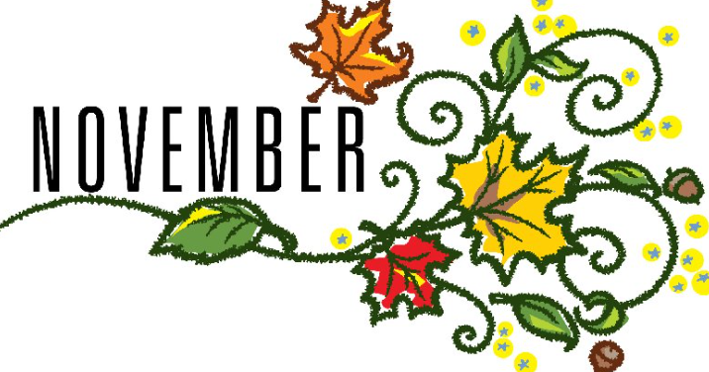
November is a great month for getting involved in any number of awareness events. Thanksgiving of course is the big holiday. It is when we usher in gratitude, appreciation, compassion, and connectivity to our communities. It is a great time to encourage others to get involved in your awareness celebrations, whether it be something tangible such as fundraising or just spreading education and awareness about your club. This month I will be sending out a bulletin to recognize International Day for the Elimination of Violence Against Women, celebrated on Nov 25. This supports The GFWC Signature Program, Domestic Violence. Also celebrated this month is National American Heritage Month, which celebrates the significant contributions of native Americans to this country. Violence Against Native American Women is a GFWC signature program. A bulletin that you can share with your members, include in your newsletter, or present at a meeting will be coming out soon on both programs. Other days of Awareness and Celebration in November
Nov. 11 Veterans Day
Nov 13 World Kindness Day
Nov 15 America Recycles Day
Nov 16-20 American Education Week
National Pancreatic Cancer Month, Lung Cancer Awareness M, Alzheimer’s Awareness Month and COPD Awareness Month.

