Looking for a great idea to support our GFWC President’s Signature Project?
It is never too early to start planning. This program is listed on the Georgia Coalition against Domestic Violence
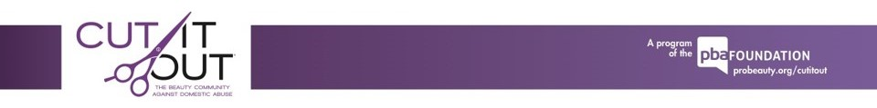
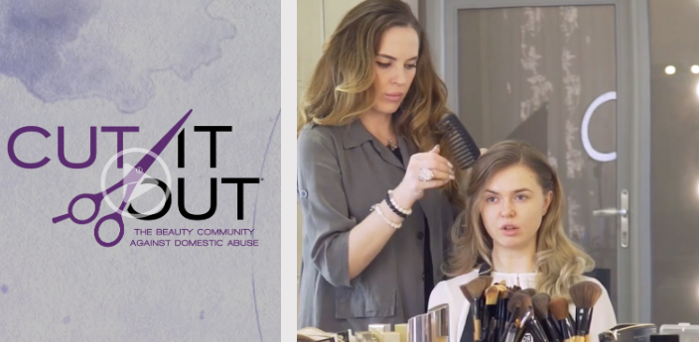
October is Domestic Violence Awareness month.

Let us start now talking with our hairdressers about implementing this program in salons and spa’s throughout the GFWC GA North West District.
CUT IT OUT® The Beauty Community Against Domestic Abuse is a program dedicated to mobilizing salon / spa professionals, students, and others to fight the epidemic of domestic abuse in communities across the United States. CUT IT OUT® builds awareness of domestic abuse through awareness materials to be displayed in salons, the “Give the Power Back” initiative to involve salons in helping local domestic violence agencies, and training salon / spa professionals and students to recognize warning signs and safely refer clients to resources.
For more information or to order complimentary awareness materials, please visit probeauty.org/cutitout.
Please share your projects, ideas and photos with me and your district members.: karenclydesdale@bellsouth.net

