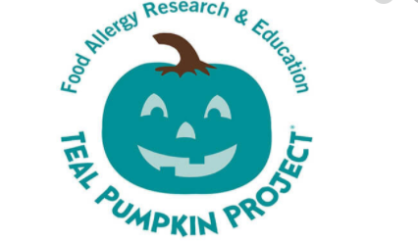

FARE Pumpkin Project Facts
1.Food allergies are a life-altering and potentially life-threatening disease, and a growing public health issue. In the U.S., one in 13 children has a food allergy – that is roughly two in every classroom. For these children, even a tiny amount of their allergen has the potential to cause a severe reaction
2.Virtually any food can cause a reaction. Many popular Halloween candies contain nuts, milk, egg, soy, or wheat, which are some of the most common allergens in children and adults.
3.Non-food treats provide a safe, fun alternative for children with food allergies and other conditions for whom candy may present a problem.

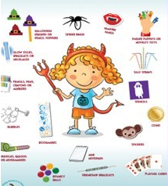
FARE Pumpkin Project Food
1.Make your home the perfect stop for all trick-or-treaters including kids with food allergies, diabetes, or other dietary restrictions. Festive celebrations nearly always include candy and treats, and it can be heartbreaking to tell a child with a food allergy or dietary restrictions that he or she cannot participate in the merriment of trick-or-treating on Halloween night.
2. Families can paint their teal pumpkin or purchase one from a local craft store. Placing it on their doorstep signifies that they will offer allergy-friendly treats in a separate bowl during trick-or-treating – or perhaps only offer the alternative treats.
3. There are many exciting, inexpensive items trick-or-treaters enjoy just as much – if not more – than candy. Some teal pumpkin treat ideas are: Bouncy balls. Bubbles, Halloween erasers or pencil toppers, Mini notebooks, Pencils, crayons or markers, Spider rings, Stencils, Stickers, Vampire fangs, Whistles, kazoos, or noisemakers.

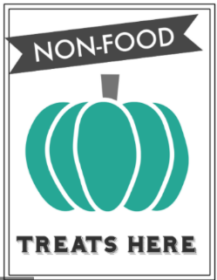
FARE Pumpkin Project Fun for families
1.Ask your friends and neighbors to learn more about the Teal Pumpkin Project and participate. Print out FARE’s flyers and hand them out.
2.Host an event like a teal pumpkin painting party and ask your friends and neighbors to participate.
3.If you have a neighborhood email listserv, / newsletter send out an email about the initiative, including a link to FARE’s website (www.foodallergy.org).
4.Reach out to your local library, dentist/doctor offices, schools, or community buildings to see if they would be willing to help you post signs or get the word out.
5.Share information on social media and post a picture of your teal pumpkins when you have them near your door! Do not forget to use #tealpumpkinproject when you post!

